Weekly Student Project Report

Date: [ From: 01/05/2024 | To: 07/05/2024 ]

Year Level: [level 1 / level 2]

Project Title: _________Sign Language Detector_________

1. What You Have Done in The Last Week (Points and Detailed):

|  |  |
| --- | --- |
| **Points** | **Description** |
| Collect dataset | We used dataset from kaggle Each training and test case represents a label (0-25) as a one-to-one map for each alphabetic letter A-Z (and no cases for 9=J or 25=Z because of gesture motions). |
| Choose right architecture | We are using neural network architecture with pytorch |
| Training model | We training this model using Google colab |

2. To-Do List for Next Week:

|  |  |
| --- | --- |
| **Student Registration number** | **Task** |
| Marwan Mohamed Ramdan 2320597 | Make a connection between a model and main file |
| Youssef Ahmed Ahmed Elmahdy 2320744 | Working on front end for the site |
| Maryam Ibrahim 2320598 | Working on ui/ux designs for the site |
| Maryam Eid 2320603 | Working on bakend of th site |
| Maryam Rezek | Working on auto-complete and convert text to speach |

3. Points in Project Not Yet Finished and Needs to be Completed:

|  |
| --- |
| **Points** |
| **Connect model with main file** |
| **make website** |
| **testing** |
| **deployment** |

4. Team Members:

|  |  |  |  |
| --- | --- | --- | --- |
| **Name** | **Reg. number** | **Detailed progress** | **%** |
| Marawan Mohamed | 2320597 | Training a model and choose right architecture | 100 |
| Youssef Elmahdy | 2320744 | Training a model | 100 |
| Maryam Ibrahim | 2320598 | Training a model | 100 |
| Maryam Rezek | 2320600 | Problem solving and testing | 100 |
| Maryam Eid | 2320603 | Searching and Collect data set and testing | 100 |

**Model structure:**

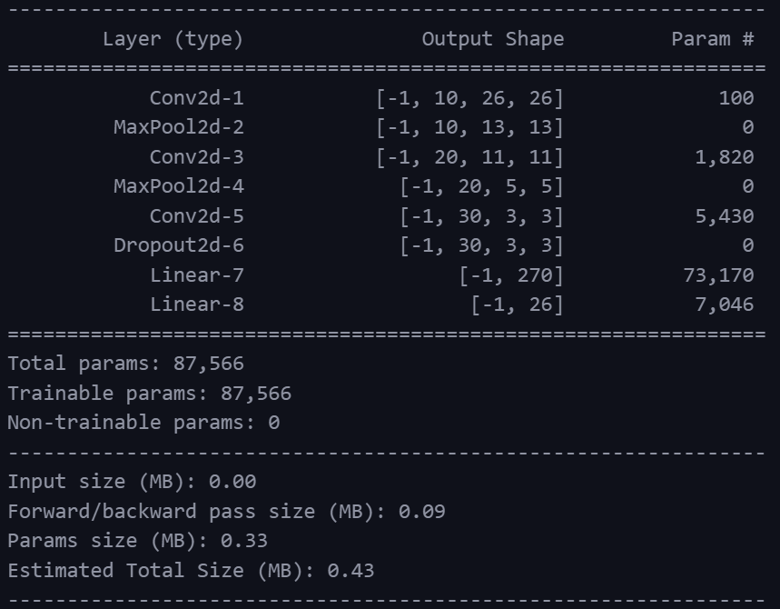

**TrainingResult:**

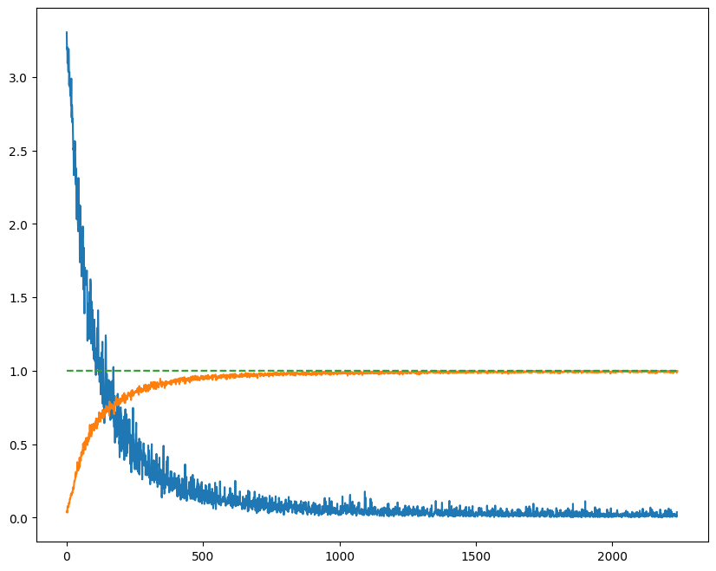

**Accuracy**

Accuracy = 0.9947550537242761 (27311/27455)

99.48%